**Lab Exercise 20- Card view in Metaflow on Localhost**

**Task Inspection with Default Cards**

Metaflow comes with a built-in *Default Card* that shows all artifacts produced by a task. Let’s create a simple flow to test it.

from metaflow import FlowSpec, Parameter, step, card  
from datetime import datetime  
  
class DefaultCardFlow(FlowSpec):  
  
 alpha = Parameter('alpha', default=0.5)  
  
 @card  
 @step  
 def start(self):  
 self.example_dict = {'first_key': list(range(10)),  
 'second_key': {'one', 'two'}}  
 self.timestamp = datetime.utcnow()  
 self.next(self.end)  
  
 @step  
 def end(self):  
 pass  
  
if __name__ == "__main__":  
 DefaultCardFlow()

The only new feature introduced in this flow is the @card decorator which attaches a card to the start step. Since no arguments are given to the decorator, the *Default Card* is used. Save the example in defaultcard.py and execute the flow as usual:

python defaultcard.py run

After the run has finished, you can open a generated card on the command line:

python defaultcard.py card view start

The command will open the card in your web browser. It will look like this:

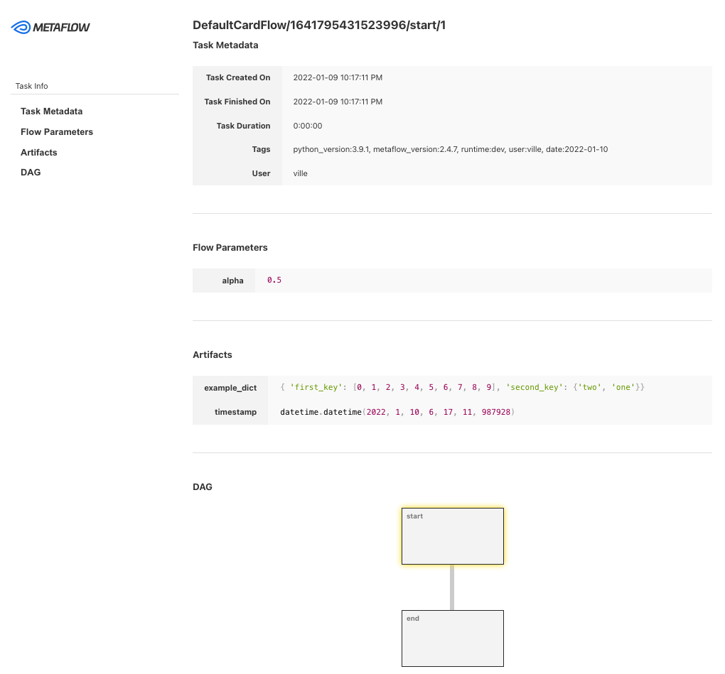

The *Default Card* shows basic metadata about the task, parameters given for the flow, artifacts accessible in the task, as well as a visualization of the flow DAG. You can use this information to quickly observe and verify results of a task without making any changes in the code.

**Using Local Card Viewer**[**​**](https://docs.metaflow.org/metaflow/visualizing-results/effortless-task-inspection-with-default-cards#using-local-card-viewer)

Local Card Viewer was introduced in Metaflow 2.11. Make sure you have a recent enough version of Metaflow to use this feature.

Opening a card manually after each run with card view can get tedious. If you have access to Metaflow UI, you can view cards automatically in the UI. If you don't have the UI deployed, Metaflow provides a simple built-in viewer, *Local Card Viewer*, which sets up a local server for viewing cards.

Open a new terminal, navigate to the same working directory where you will be executing flows, and run this command

python defaultcard.py card server

In your browser, go to [localhost:8324](http://localhost:8324/). You should see the latest card created with a header that allows you to navigate through all cards produced by the latest run:

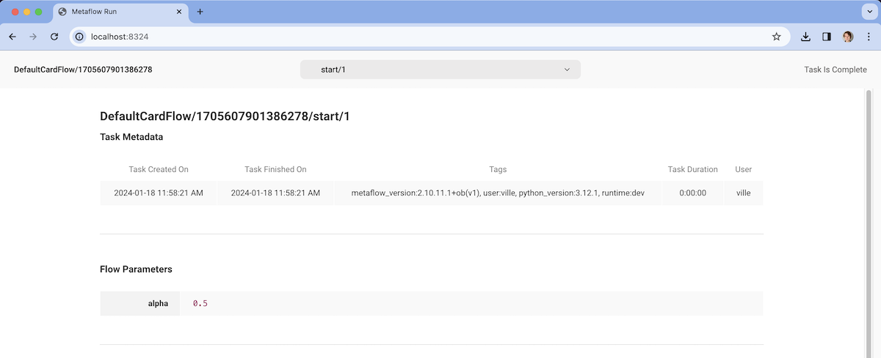

If you run the flow again

python defaultcard.py run

from metaflow import step, FlowSpec, current, card

from metaflow.cards import Markdown, ProgressBar

class ClockFlow(FlowSpec):

@card(type="blank", refresh_interval=1)

@step

def start(self):

from datetime import datetime

import time

m = Markdown("# Clock is starting 🕒")

p = ProgressBar(max=30, label="Seconds passed")

current.card.append(m)

current.card.append(p)

current.card.refresh()

for i in range(31):

t = datetime.now().strftime("%H:%M:%S")

m.update(f"# Time is {t}")

p.update(i)

current.card.refresh()

print(t)

time.sleep(1)

m.update("# ⏰ ring ring!")

self.next(self.end)

@step

def end(self):

pass

if __name__ == "__main__":

ClockFlow()

python clockflow.py card server --poll-interval 1